
INFORMATIONAL BULLETIN 2025-4
QA3600 and GT30 EFI Throttle Wiring Harness 50-1702
Valued Customer,
Thank you for purchasing a Stinger QA3600 or GT30
Summary: Stinger Equipment has identified a batch of defective EFI Throttle Wiring Harnesses (Part No. 50-1702). These units do not meet our manufacturing specifications and must be replaced.
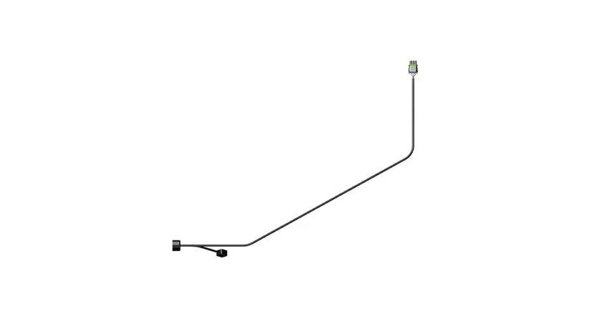
Why: The affected wiring harnesses were produced incorrectly and are not compliant with Stinger Equipment’s technical standards.
Serial Number Range:
GT30: GT30-80001 to GT30-80087
QA3600: QA3600-80014 to QA3600-80027

Recommendation: Please contact our Technical Support team at (502) 536-0716 ext. 2 to arrange for a replacement harness. Please be prepared to provide the serial number of your equipment to facilitate the replacement process.
There will be no cost for the replacement harness. Stinger Equipment will cover shipping via FedEx Ground.
Please contact your dealer, distributor, or the factory with any questions
Thank you for being a Stinger customer!

